Solution Design Document
Inflight Changes for EMAP & i2i Business Units
04-Oct-2013
CloudSense
08
Fall
Contents
1. Executive summARY 3
1.1. KEY HIGHLIGHTS 3
1.2. BUSINESS OPPORTUNITY 3
1.3. Assumptions 3
2. Project scope 4
2.1. In-scope 4
2.2. Out of Scope 5
3. Solution Overview 7
3.1. New Order Process 7
3.2. Inflight Change Process 7
3.3. Inflight Change Types - Description 8
3.3.1. Contract Amendment 8
3.3.2. Contract Correction 8
3.3.3. Contract Cancellation 8
3.3.4. Other Changes 8
3.4. Process Flow Diagrams 8
3.4.1. High Level Process Flow 8
3.4.2. Detailed Process Flow – Sales Team Initiated IFC Process Flow 10
3.4.3. Detailed Process Flow – SOP Team Initiated IFC Process Flow 10
3.5. Key Field Values 11
3.5.1. Opportunity Stage Field Values during IFC process 11
3.5.2. Status & Billing Status Field Values during IFC process 11
3.5.3. Contract Amendment – When Invoice By = “Order” 12
3.5.4. Contract Amendment – When Invoice By = “Order Group” 16
3.6. Approval Process 18
3.6.1. Case Object Approval Process 18
3.6.2. Opportunity Object Approval Process (For Downsell Scenarios) 19
3.7. CRM & Financial Force Interface 20
3.8. Deferred Revenue Process 22
3.9. Excluding Subscription orders from Invoicing (EMAP Specific) 23

- Executive summARY
This document details the solution design for deploying in-flight change (IFC) process to customer orders in EMAP & i2i business units.
  - KEY HIGHLIGHTS
- Enable the following IFC processes for EMAP & i2i Events business units of TRG
- Contract Amendments
- Contract Corrections
- Contract Cancellation
- Enable the CRM-FF interface to support the IFC process
- Perform necessary data updates to ensure that existing orders are able to participate in the IFC process
  - BUSINESS OPPORTUNITY
CloudSense and Financial Force have implemented a Lead to Cash process across all TRG business units, handling Sales, Provisioning and Invoicing processes. However, the EMAP & i2i business units do not have the capability to process changes to orders. If customers need changes to their existing orders either to upgrade, downgrade, cancel or to correct, the only option available to them is to cancel the existing contract and process a new contract with the changes requested by the customer. This process involves significant overhead to these business units as the SOP teams have to credit all invoices generated from their existing contract and then setup the new set of invoices. Also, the current process does not offer a good customer experience as the customers receive multiple invoices and credit notes.
The functionality is therefore required to allow changes to orders in a manner that it reduces the overhead associated with the current process and it improves the customer experience.
  - Assumptions
This Solution does not include the functionality or integration required for managing the floor plan (as that solution does not exist today)
- Project scope
  - In-scope
- Business Units in scope for IFC process rollout
- EMAP
- i2i Events
- Change types in scope
- EMAP Business Unit
- Advertising
- Date changes (i.e. Issue Date / Period changes)
- Attribute changes (i.e. Size, position, placement etc)
- Order changes due to an Issue/Feature not happening
- Cancellations
- Add-Ons
- Incorrect / Missing Agency Commissions or Discounts
- Invoice content changes
    - Missing PO numbers
    - Incorrect VAT numbers
- Company Name changes
- Company Address changes
- Billing Schedule changes
- Events
- Delegate Pass Upgrades
- Delegate Pass Downgrades
- Cancellations
- Add-Ons
- Company Name changes
- Company Address changes
- Attendee detail changes
- Incorrect or Missing discounts
- Billing Schedule changes
- i2i Events Business Unit
- Exhibitions
- Stand Upsize
- Stand Downsize
- Space type switch
- Move Stand to a Premium Location
- Order Refund
- Cancellations
- FOC Stand Upsize
- Add Brands to Stand
- Missing Agency Commissions
- Incorrect TAX (VAT) applied
- Incorrect Discount Applied
- LSE’s
- Delegate Pass Upsell
- Delegate Pass Downsell
- Cancellations
- Add-Ons
- Company Name changes
- Company Address changes
- Attendee detail changes
- Incorrect or Missing discounts
- Billing Schedule changes
- Perform data updates to existing orders to ensure they are available for IFC process.
- Perform changes to i2i Exhibitions renewals process to ensure that opportunities copied over from previous years event contain updated versions of product configurations.
- Update TRG Event Attendee Bookings, created for event orders, during the IFC process.
  - Out of Scope
- Changes to IFC process that currently exist for 4C group brands.
- Automated Cancellation Policy implementation in the event of order cancellations
- Rollout of ClickApprove to enable customer e-signature as part of IFC process

- Solution Overview
  - New Order Process
A typical new order sales process would involve a TRG Account Manager / Sales executive (will be referred as TRG users) creating an opportunity within Salesforce. During the sales process, TRG users would complete configuring necessary products using CloudSense Product Configurator application as per the needs of the customer. Upon completion of the product configuration process, TRG users would then take the customers through the quotation and contract execution process. Once the customer signs the contract, TRG users would then set the opportunity to closed-won status. This process of setting the opportunities to closed won status would trigger automatic generation of Orders within Salesforce.
The next step in the process would involve the Sales Order Processing (SOP) team reviewing orders that get generated from closed won opportunities. If the SOP team has all the information that they need for order fulfillment processes, they would set billing status to “Ready For Billing”. This ensures that the orders get picked up for billing by FinancialForce (FF) application. Depending on the billing instructions (i.e. Billing Frequency, Payment Terms etc) agreed with the customer during the contract review process, the customer will be billed by FF.
Basically TRG has two options when it comes to billing a customer. Either the customer gets billed for each and every order individually (i.e. Invoice By = “Order”) or the customer gets billed for all their orders put together (i.e. Invoice By = “Order Group”). The “Invoice By” field on the Opportunity object captures the preference to bill by order vs order group.
  - Inflight Change Process
Inflight Change Process (IFC) commence when customers request changes to their existing orders.
The order changes requested by EMAP & i2i Events business units will be categorized as follows

Change Type | Change Sub-Type
Contract Amendment | Upsell
Contract Amendment | Downsell
Contract Amendment | Add On
Contract Amendment | Order Cancellation
Contract Cancellation | Order Group Cancellation
Contract Correction | Missing / Incorrect Agency Commission
Contract Correction | Missing / Incorrect Discounts
Contract Correction | Incorrect Company Billed
Contract Correction | Incorrect Product Billed
Other Changes | Company Name Changes
Other Changes | Company Address Changes
Other Changes | Billing Schedule Changes
Other Changes | Incorrect / Missing PO details in invoices
Other Changes | Incorrect / Missing VAT no in invoices
Other Changes | Incorrect VAT (Tax) applied
Other Changes | Attendee Detail Changes
Other Changes | Issue Date Changes

  - Inflight Change Types - Description
    - Contract Amendment
When customers want to do an upgrade or a downgrade or require additional products (add-on) added to their current contract or cancel one of their existing orders, they need to be put through the Contract Amendment process. During a contract amendment process, the system would act on the specific order that the customer wants amended and the process would involve the TRG user going through the sales process on the InFlight Change (IFC) opportunity. Once the IFC opportunity is set to closed won status, change orders are generated and depending on whether the change orders are for Events or for Advertising revenue stream, the system would update the replaced orders (i.e. old orders) with appropriate status. These change orders are invoiced per instructions contained in the IFC opportunity.

    - Contract Correction
When customers want to make changes to their contract with TRG either because they weren’t given discounts/commissions or invoices were sent to the wrong Billing Account or they signed up to incorrect products etc, they need to be put through the Contract Correction process. During contract correction process, the system would create an Inflight change opportunity and copy over all orders from the original opportunity. The TRG user will then go through the sales process with the customer. Once the IFC opportunity is set to closed won status, change orders will be generated and once SOP team review & activate the change orders, the original opportunity and all associated orders would be set to replaced status.

    - Contract Cancellation
When customers change their mind and want to cancel their contract with TRG either because they are not happy with the service that they received or because the product is not a right fit for their purpose or for whatever reason, they need to be put through the contract cancellation process. During Contract Cancellation process, the system would set all the orders associated with the contract to cancelled status. When the orders are in cancelled status, all outstanding invoices associated with the orders will be cancelled by FF.
    - Other Changes
Changes requested by customers that does not have a revenue impact are categorized under this group.
  - Process Flow Diagrams
    - High Level Process Flow
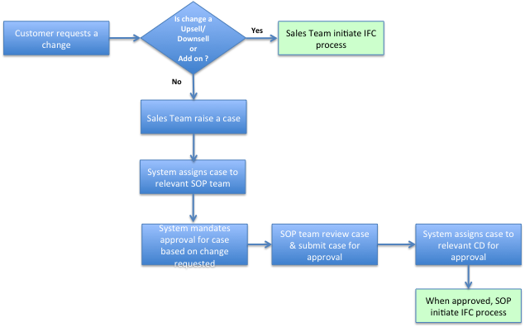

    - Detailed Process Flow – Sales Team Initiated IFC Process Flow
      - (View these diagrams with 500% Zoom)
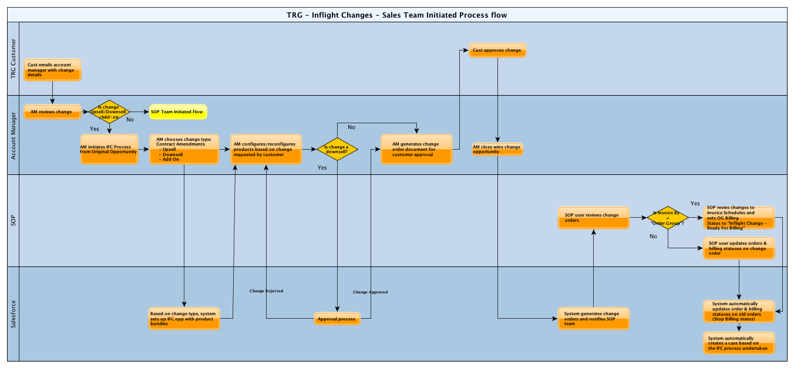

    - Detailed Process Flow – SOP Team Initiated IFC Process Flow
      - (View these diagrams with 500% Zoom)
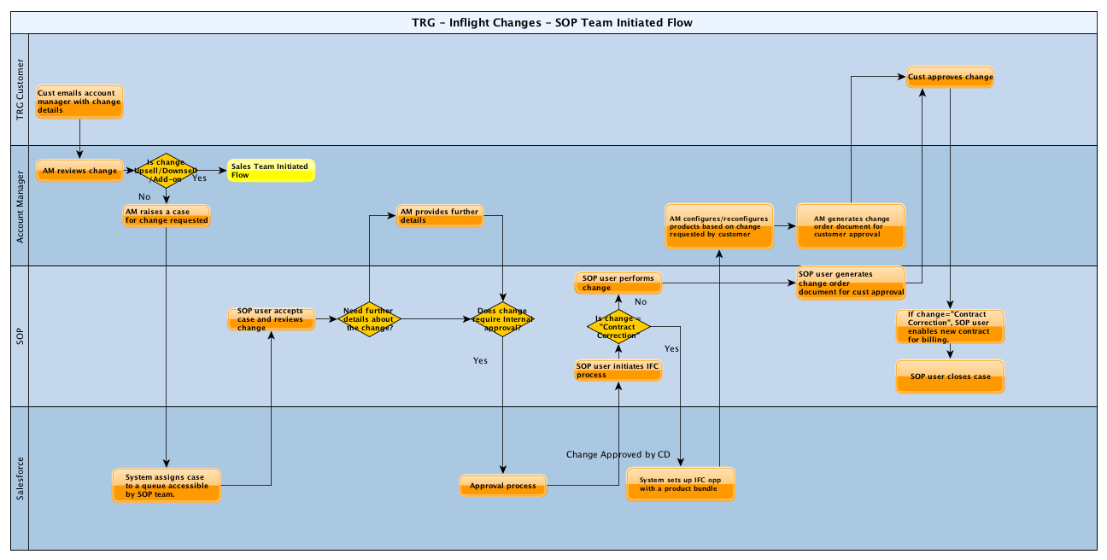

  - Key Field Values
    - Opportunity Stage Field Values during IFC process
The following table lists the opportunity stage field values for both the original opportunity and the Inflight Change opportunity when Invoice By = Order.
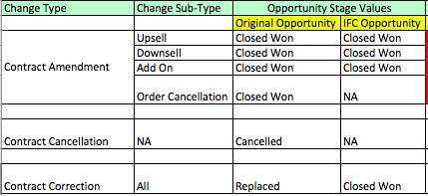
    - Status & Billing Status Field Values during IFC process
The following table lists the status (Order Group Status or Order Status and Billing Status) field values during IFC process for the following scenarios:
- Invoice By = “Order Group”
- Invoice By = “Order”
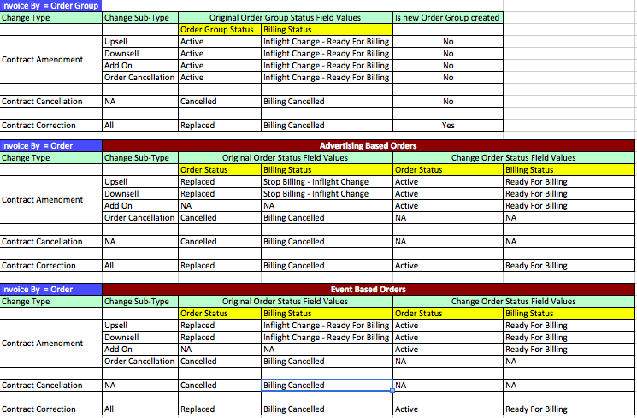

    - Contract Amendment – When Invoice By = “Order”
During Contract amendment scenarios (i.e. Upsell / Down-sell / Add-on) of the Inflight change process, when the Inflight Change opportunity is set to closed won status, the orders that it generates will be associated with the original order group and original opportunity. This is done to ensure that FF is able to process the invoices per existing interface definition rules. The change orders will have links to original opportunity as well as to the Inflight Change opportunity (new field will be named as Created by Opportunity)
Upsell / Downsell
For both Upsell and Down-sell scenarios, a new IFC (InFlight Change) opportunity will be created for the order that undergoes upsell / downsell. When the IFC opportunity is set to closed won status, a change order will be generated from the IFC opportunity. When the change order is set to “ready for billing” status, the replaced order, whose current status would be “Inflight change – review in progress”, will either be set to “Stop Billing – Inflight change” or “Inflight Change - Ready for Billing” depending on the product.
For Event based products, the system is designed to present just the upsell or down-sell value and not the full value of the product. For example, if the initial order for a standard delegate pass was £ 100 and the customer wants to upgrade to a premium pass with a price tag of £ 250, the system will be creating an opportunity for £ 150 (i.e. £250 – £100), which is the upsell value and not the full value. In the event of a down-sell scenario, the order will have a negative value. The replaced (old) order will still continue with its invoicing schedule and the change order will have its own invoicing schedule if it is an upsell and a manual credit note will be raised in the event of a down-sell.
For Advertising based products, as it is complex to determine upsell / down-sell price, the system is designed to present the full value and not the upsell / down-sell value. Hence, for such products, the change orders will have an invoicing schedule but the replaced orders (old) invoicing schedules will be cancelled.

Scenario Representation
Step 1 – New Opportunity & new orders
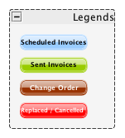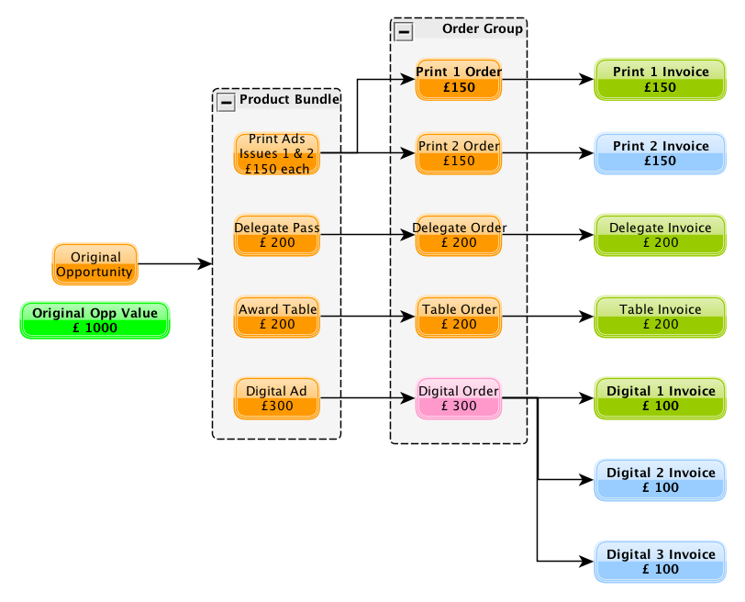

Step 2 – Change order
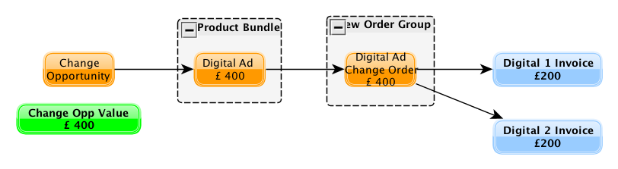
Step 3-Changes to original opportunity & original order
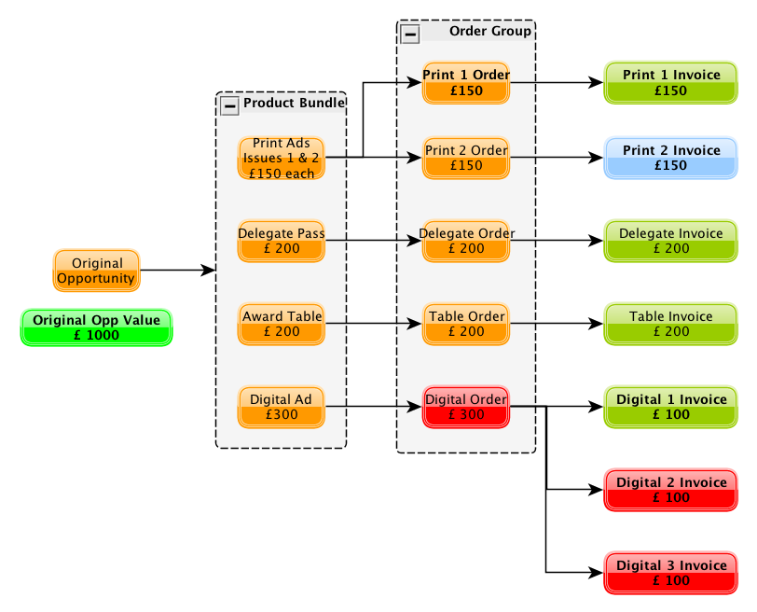
Add-on
When an Add-on contract amendment is processed, a new IFC opportunity will be created. When the IFC opportunity is set to closed won status, a change order will be generated from the IFC opportunity. Since an add-on contract amendment is not a change to any of the existing orders, the new add-on change order will not impact any of the existing orders. The “Ready for Billing” Billing status set on the change order should instruct FF to create an invoicing schedule per billing frequency on the change order.
Order Cancellation
When an order cancellation is processed, the order billing status will be set to “Billing Cancelled”. This status should instruct FF to stop issuing further invoices on the cancelled order.

    - Contract Amendment – When Invoice By = “Order Group”
Upsell / Downsell
For both the scenarios, a new IFC opportunity will be created for the order that undergoes upsell / downsell. When the IFC opportunity is set to closed won status, a change order will be generated from the IFC opportunity. The CRM application would perform a calculation to determine the updated contract value for advertising products. The CRM application would also set the “Do Not Invoice” flag to true on the Order Line Items associated with the replaced order. The CRM application will create a new TRG Invoice Schedule record (with Invoice Type = “Catch-up” for Upsell and Invoice Type = “Credit” in the event of a down-sell of event based products) required specifically for the change order to bring the change order invoiced % in line with other orders. Once the catch-up invoice or credit invoice is issued depending on whether the change is an upsell or a down-sell (event based products), subsequent invoices (with invoice type = “Normal”) will be generated for all active orders that are part of the order group.
When the IFC process is initiated, the Order Group billing status will be set to “Inflight change – Review in Progress”. When FF encounters this status, it should stop processing further scheduled invoices related to the order group. After the IFC process is completed and the Order Group billing status is set to “Inflight change – Ready for billing”, FF application should cancel all its scheduled invoices related to the Order Group and create new scheduled invoices per the new instructions from TRG Invoice Schedule object.

Scenario Representation:
Step 1 – New Opportunity & New Orders
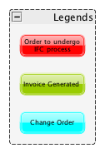
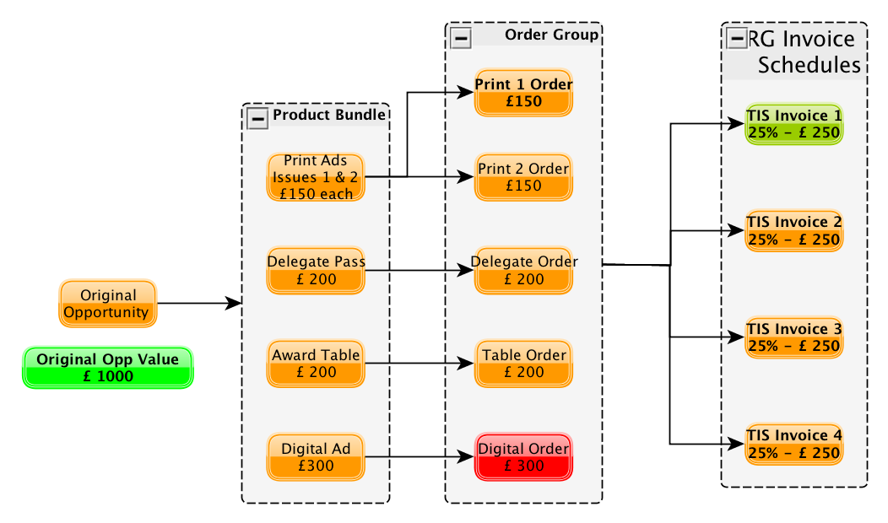
Step 2 – Change order & changes to original opportunity & original order group
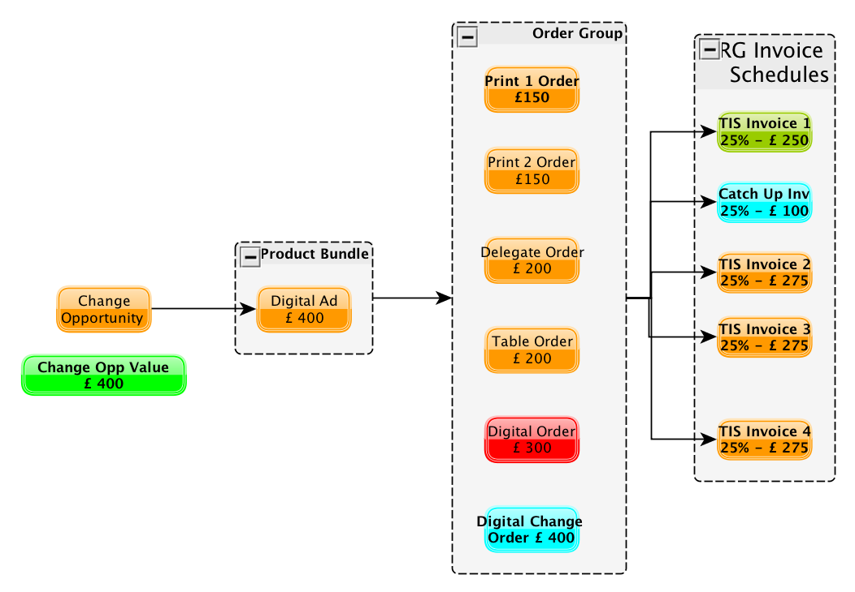

Add-on
When an Add-on contract amendment is processed, a new IFC opportunity will be created. When the IFC opportunity is set to closed-won status, a change order will be generated from the IFC opportunity and will be associated back with the same order group. Since an add-on contract amendment is not a change to any of the existing orders, the new add-on change order will not impact any of the existing orders. The CRM application will create new TRG Invoice Schedule record with Invoice Type = “Catch-up” for the change order. This ensures the change order is invoiced to the same level as other orders in the order group. Once the catch-up invoice is issued, subsequent invoices (with invoice type = “Normal”) will be scheduled for all active orders that are part of the order group.

Order Cancellation
When an order cancellation is processed, the CRM application will set the Order Group billing status to “Inflight change – Review in progress”. This should instruct FF to stop issuing further sales invoices related to the order group. The CRM application will perform a calculation to determine the revised contract value. (I.e. deduct the un-invoiced percentage on the order that is getting cancelled from the overall contract value). The CRM application will also set the “Do Not Invoice” flag to “True” on the cancelled order.
The SOP team, after adjusting the outstanding invoices on the TRG Invoice Schedule object, will then set the Order Group billing status to “Inflight change – Ready for billing”. FF should then cancel all its scheduled invoices related to the Order Group and create new scheduled invoices per the new instructions from TRG Invoice Schedule object.

  - Approval Process
    - Case Object Approval Process

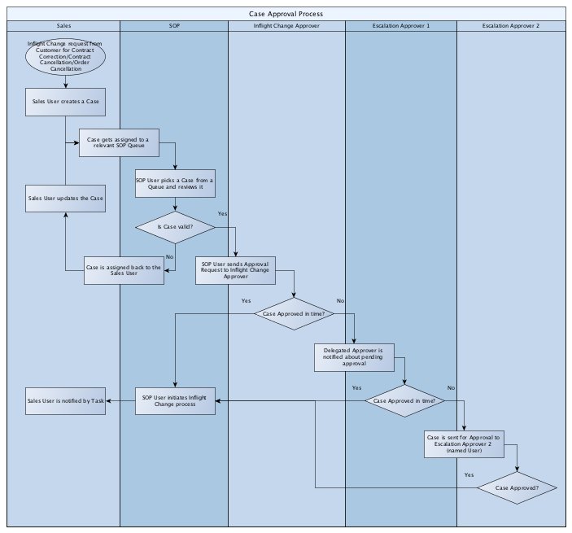
Case Object Definition:
Record Type = “Inflight Change”
Field Name | Description
Business Unit | List of all TRG Business Units
Brand | Lists all Brands
Type | Lists all IFC Types (i.e. Contract Amendment, Contract Correction etc)
Sub-Type | Lists all IFC sub-types (i.e. Upsell, Downsell, Issue Date Change etc)
Opportunity | To be populated with Opportunity that is undergoing IFC process
Order | This field is mandated for following Sub-Types - Upsell, Downsell, Add-On, Order Cancellation, Issue Date Changes
Product | Formula field which specifies the name of the product and which will be derived from Order object.
Status | Lists all applicable statuses for the case object record. i.e. (New, In Progress, Approval Required, Approval Requested, Approved, Rejected, Closed)
Subject | Subject for the change requested by the customer
Description | To capture additional details about the change
Inflight Change Approver | Will be populated with the approver details depending on the owner of the opportunity
Priority | Low, Medium, High
Case Origin | Defaulted to “Manual Entry”
Case Reason

    - Opportunity Object Approval Process (For Downsell Scenarios)
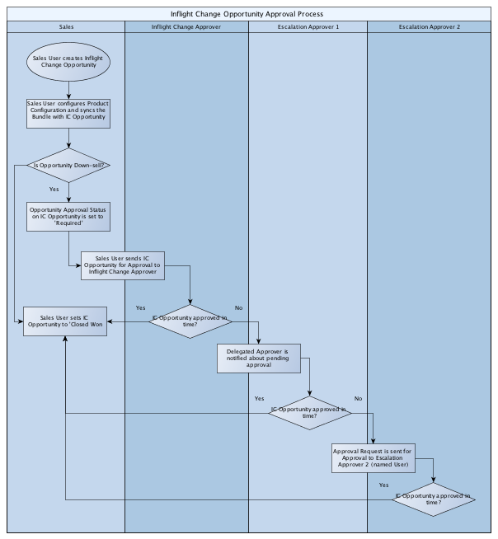
  - CRM & Financial Force Interface
When invoice by = “Order Group”, TRG Invoice Schedule object will contain the invoicing instructions that FF would require in order to process invoices. The following table lists the fields from this object.
TRG Invoice Schedule Object fields:
Field Name | Description
Invoice Date | The first invoice date will be set to the billing start date and subsequent invoices will need to be defined by the sales team
Invoice Value % | This will be set based on the value from the Opportunity Invoice Type Template field set at an opportunity level by Sales. (i.e. 20-40-40, 3 installments etc)
Invoice Amount | This is auto-calculated based on the invoice % and the Total Contract Value.
Invoice Type | This field will contain the following values: Normal, Catch-up, Credit Note
Order | When Invoice Type = “Catch-up” or “Credit Note”, this field needs to be populated with the change order record id.
Sales Invoice | Once FF generates an Invoice, it needs to populate the Sales Invoice record id into this field.
Status | This field will contain the following values: None, Ready for Billing, Billing Generated
Order Billing Group Status | Formula field that derives the Billing Status field value from the Order Group
Sales Credit Note | Once FF generates an Sales Credit Note, it needs to populate the Sales Credit Note record id into this field.
Original Opportunity | This field relates the TRG Invoice Schedule record to the Original Opportunity
Original Order Group | This field relates the TRG Invoice Schedule record to the Original Order Group

Once an Order Group Billing Status is set to “Ready For Billing” or “Inflight Change – Ready for Billing”, FF should select records that belong to the Original Opportunity from TRG Invoice Schedule object, with the following criterion.
Order Group Billing Status = “Inflight change – Ready for billing” or “Ready for billing”
Status = “Ready for billing”
Invoice Date <= Today’s date
Once a Sales Invoice is raised by FF, FF should do the following updates into the TRG Invoice Schedule object:
Update Billing Status field on the Order Group object to “Billing Active” or “Billing Complete”.
Update Status field on TRG Invoice Schedule object to “Invoice Generated” status
Update Sales Invoice field on TRG Invoice Schedule object with the Sales Invoice ID.
Update Sales Credit Note field on TRG Invoice Schedule object with the Sales Credit Note raised. This is only applicable for invoices that have their Invoice Type set to “Credit”.
When Invoice By = “Order”, FF continues to operate in the same manner as it does currently i.e. depending on the Billing status (either “Ready for billing” or “Inflight change – Ready For Billing”), Billing Start Date (<= Today’s date), FF would create invoice schedules depending on the Billing Frequency specified in the Order object. These invoice schedules will then create Sales Invoices on the specified Invoice Date.
  - Deferred Revenue Process
It is understood that Deferred Revenue Process will not be enabled for EMAP business. However, for i2i, the existing deferred revenue process will continue to remain in place. From a CRM standpoint, the following will be enabled towards setting the service start & end dates.
CRM will populate the order object service start & end dates based on the product that the order is associated with.
For Inflight change orders, when order status of the original order is either set to “Replaced – Inflight change” or “Cancelled”, the CRM application will update the service end date accordingly.
Service Start & End Dates by Products
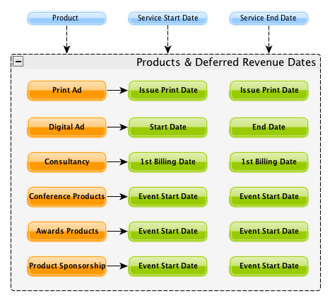
  - Excluding Subscription orders from Invoicing (EMAP Specific)
All orders specific to EMAP (opportunity record type = EMAP) will have the following fields populated:
Revenue Type (Revenue_Type__c)
Revenue SubType (Revenue_Sub_Type__c)
For Subscriptions: Revenue Type = “Subscriptions”. So this information should be used to ignore order specific to subscriptions. But if a subscription order is part of Invoice By = “Order Group”, then the order & order lines specific to subscription product needs to be considered in the invoice.

